

DBHD Geological Disposal Facility plan are ready to use
________________________________________________________

after 15 years of research and development – finally SAFE DBHD GDF

Dipl.-Ing. Volker Goebel and Physicist Dr. Herres – both Europe / Germany seem

shows you DBHD HLW GDF – in Deep Saltrock – under a 1.100 m Sediment-Lid.

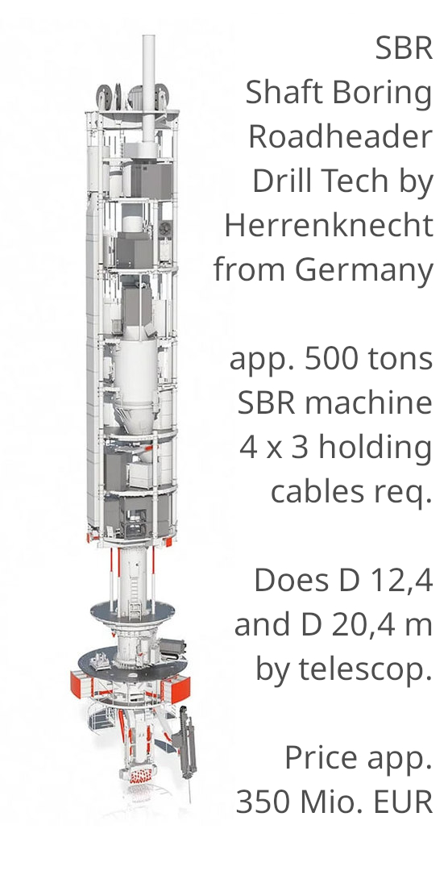
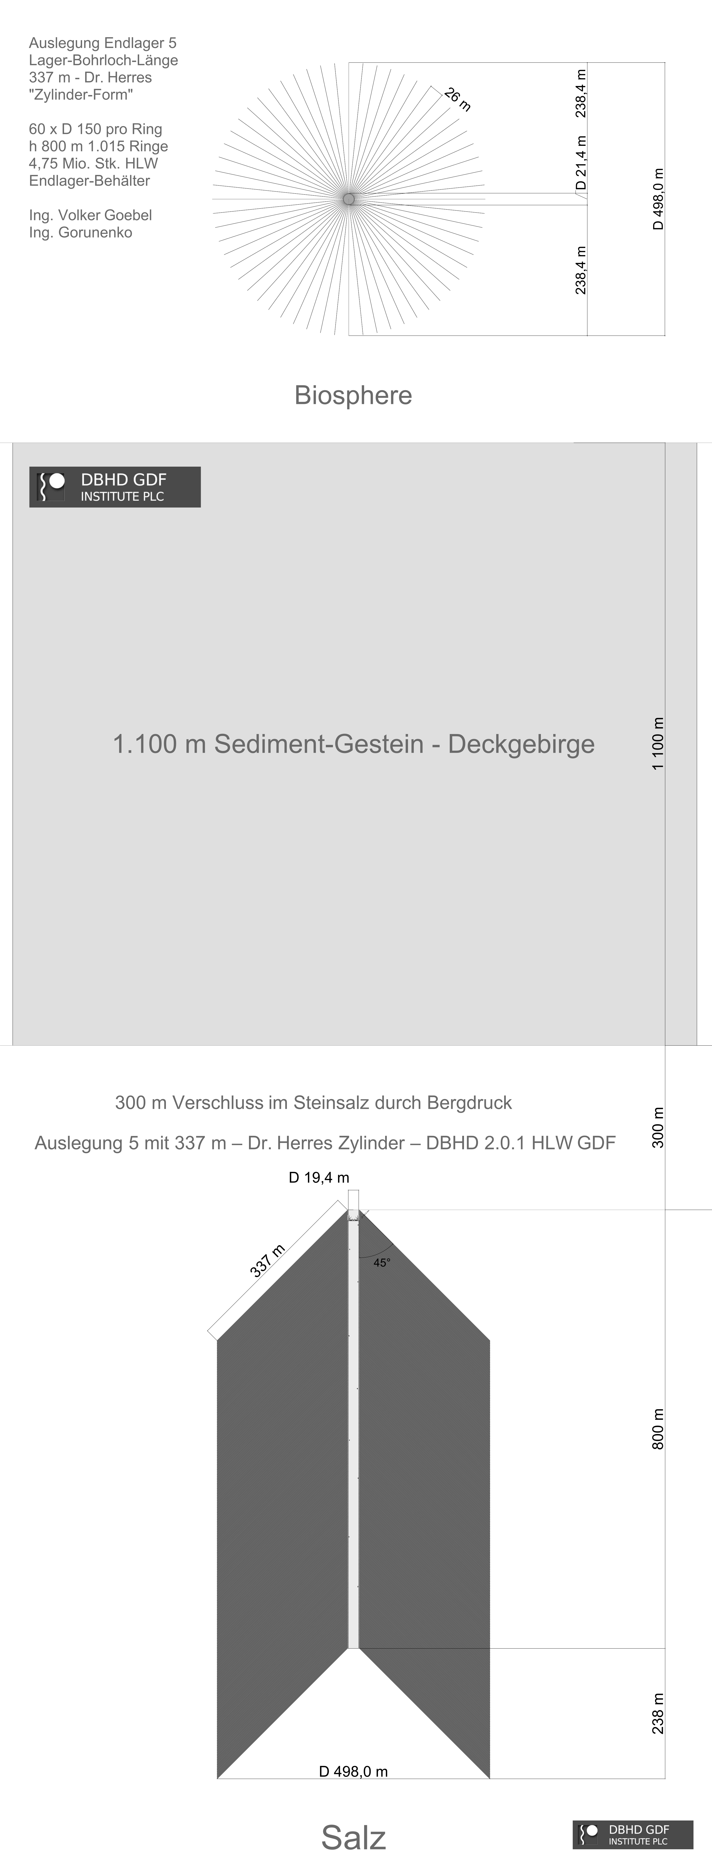

DBHD HLW GDF stores 4.750 tons net (Mg net) in a usual GDF – they work with

thermodynamic calculations to tailor the GDF to decay heat of the high level

waste burried there. – Deep, therefore dry, with gas-tight closure, and proof of

eternal undercriticalness under GDF conditions pressure an heat.

Here you see the 1 kg Inventory GDF Container with its lead-transport hull :

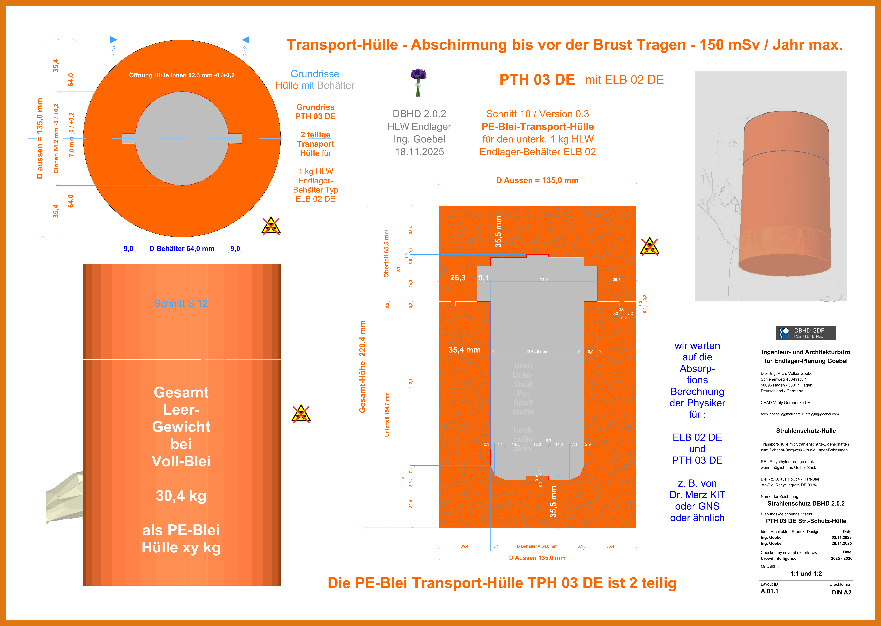
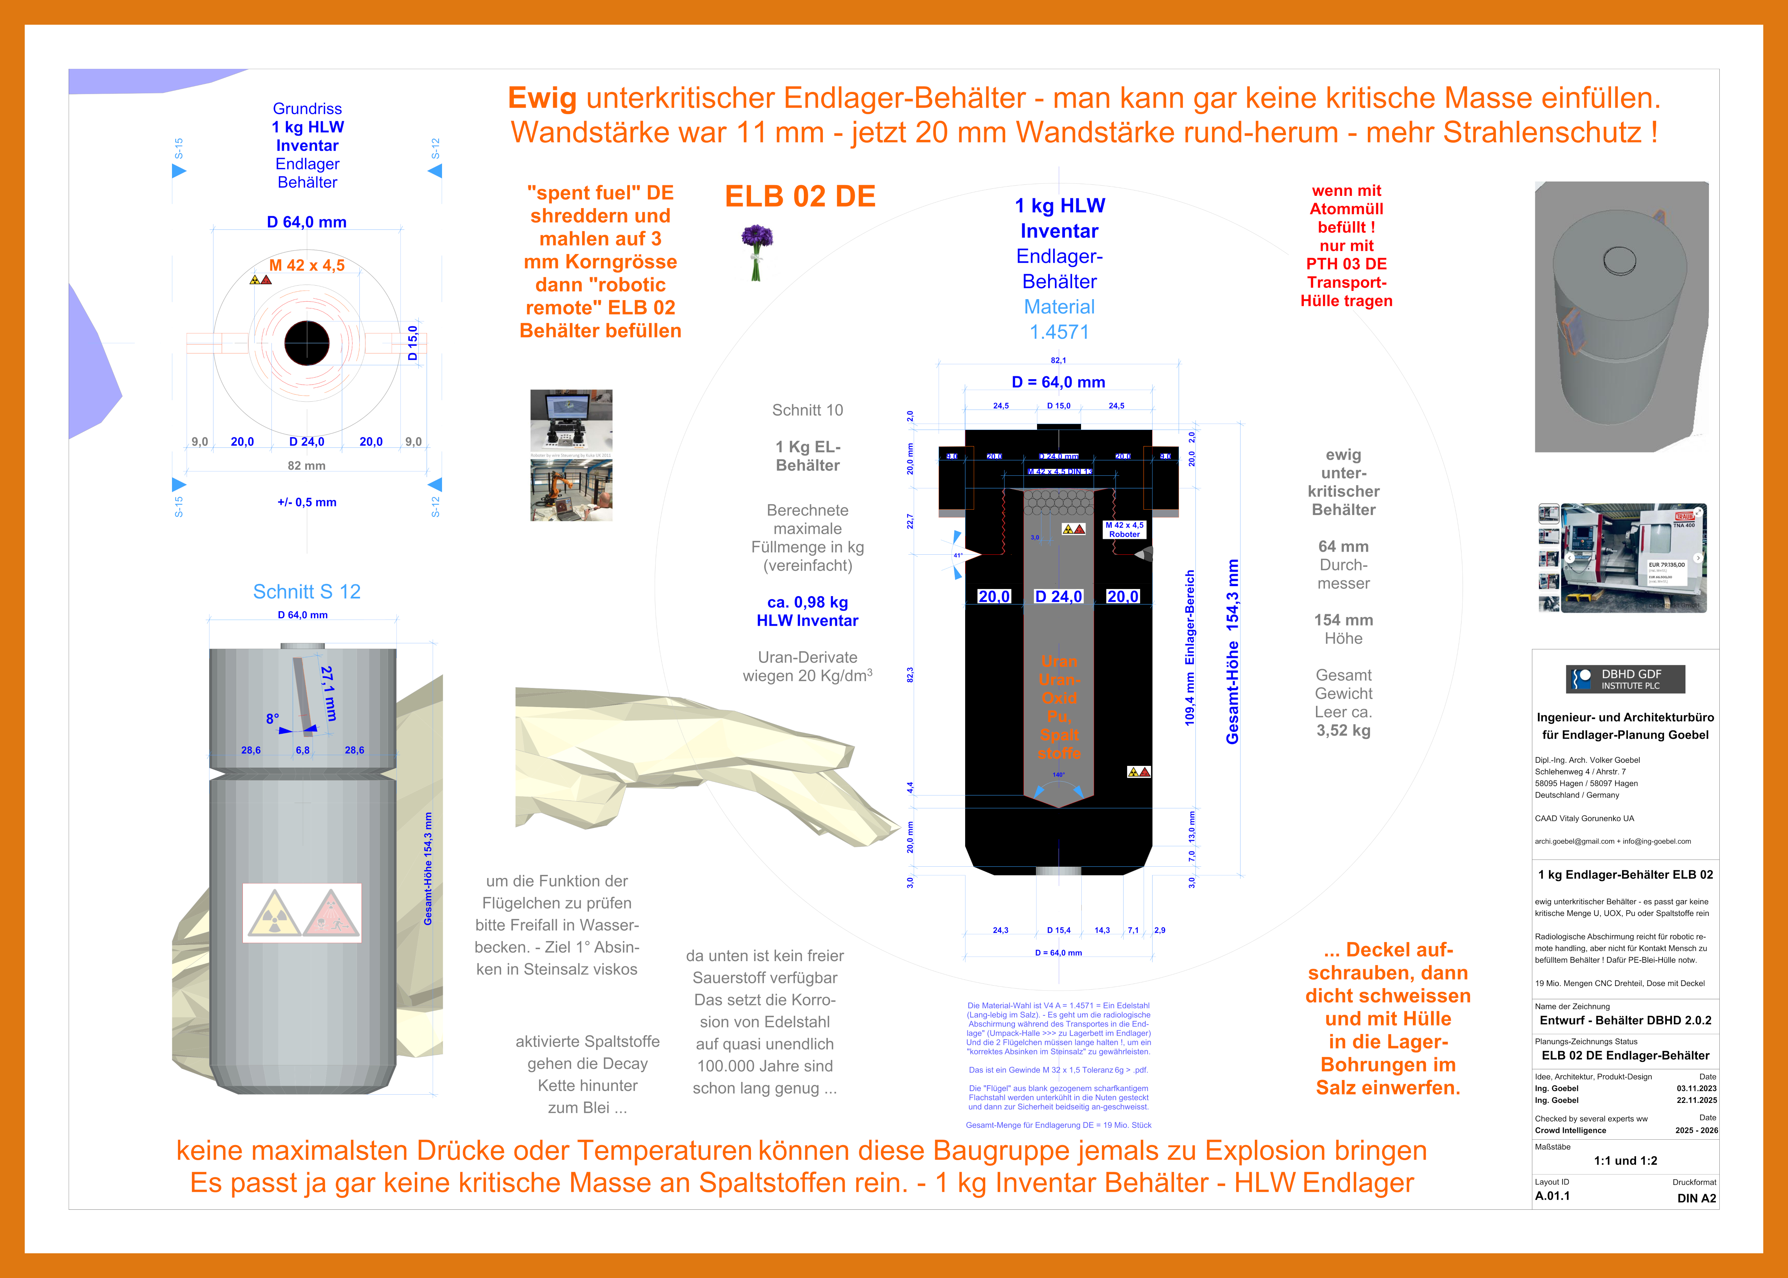

It turned out that the GDF Container ELB 02 DE and Transport-Hull PTH 03 DE

actually make GDF possible. – What we all know. Containers have to be filled.

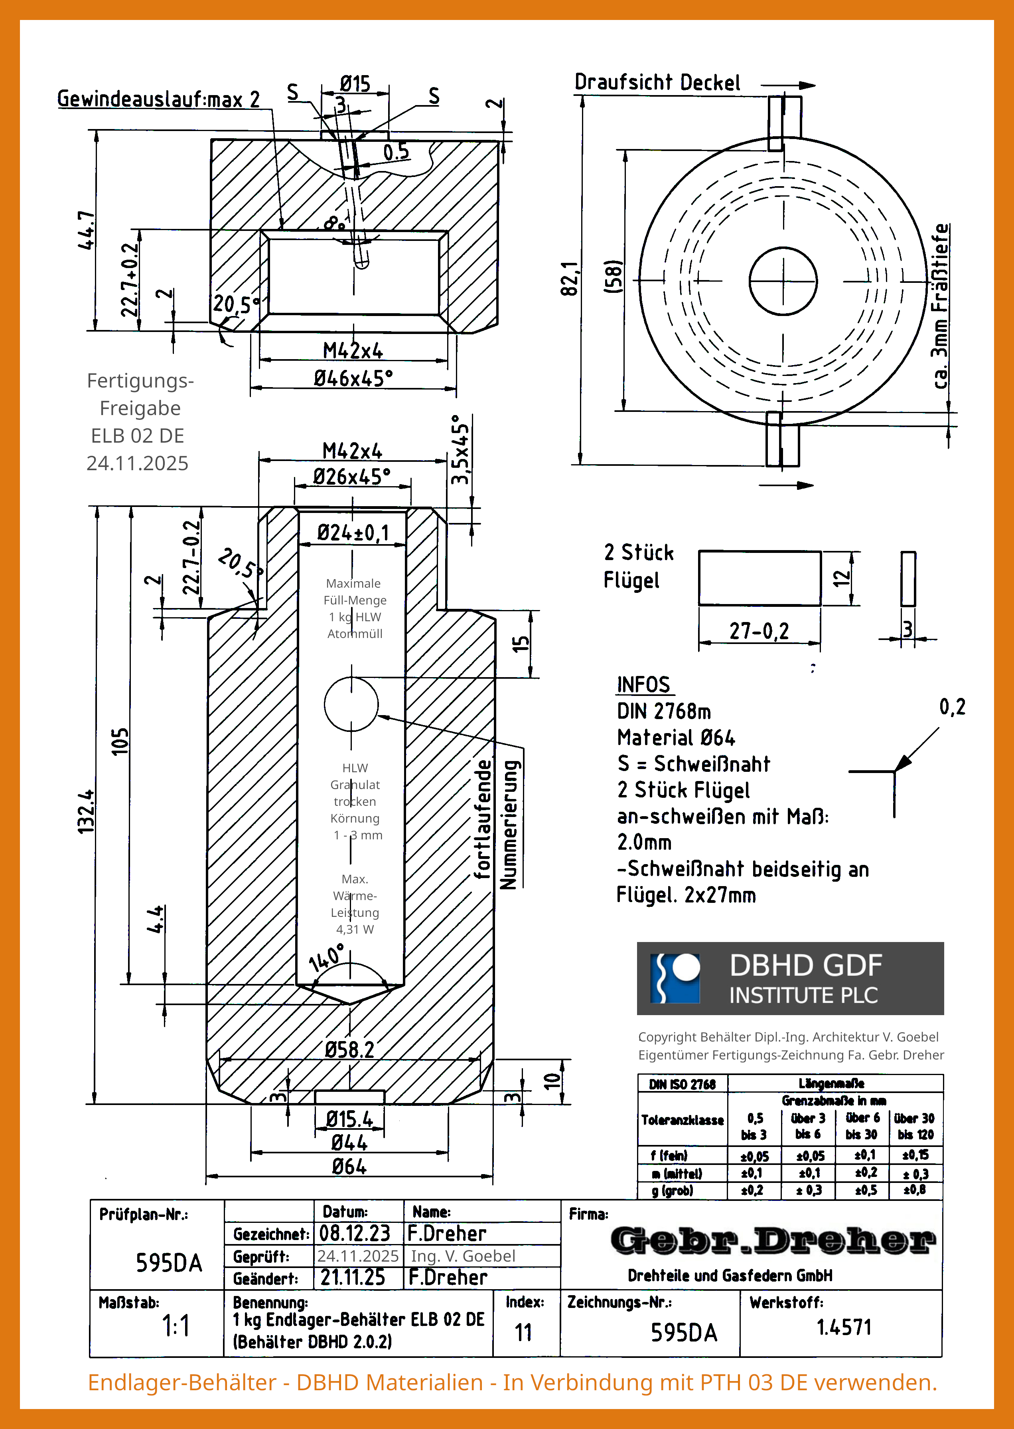
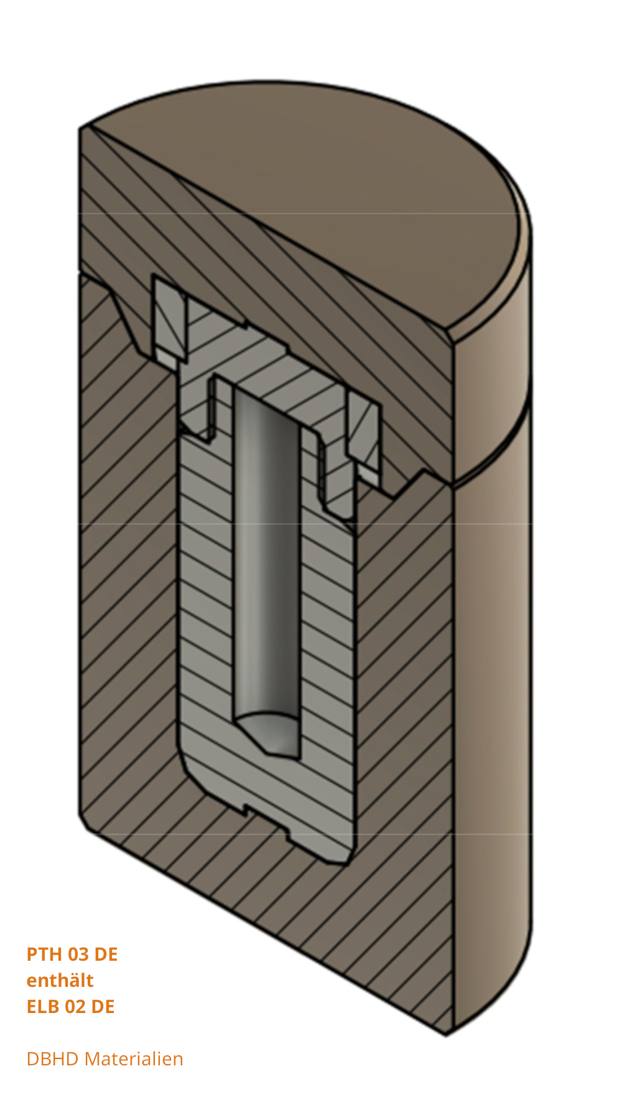

And this is how DBHD HLW Geological Disposal Facility looks while building it.

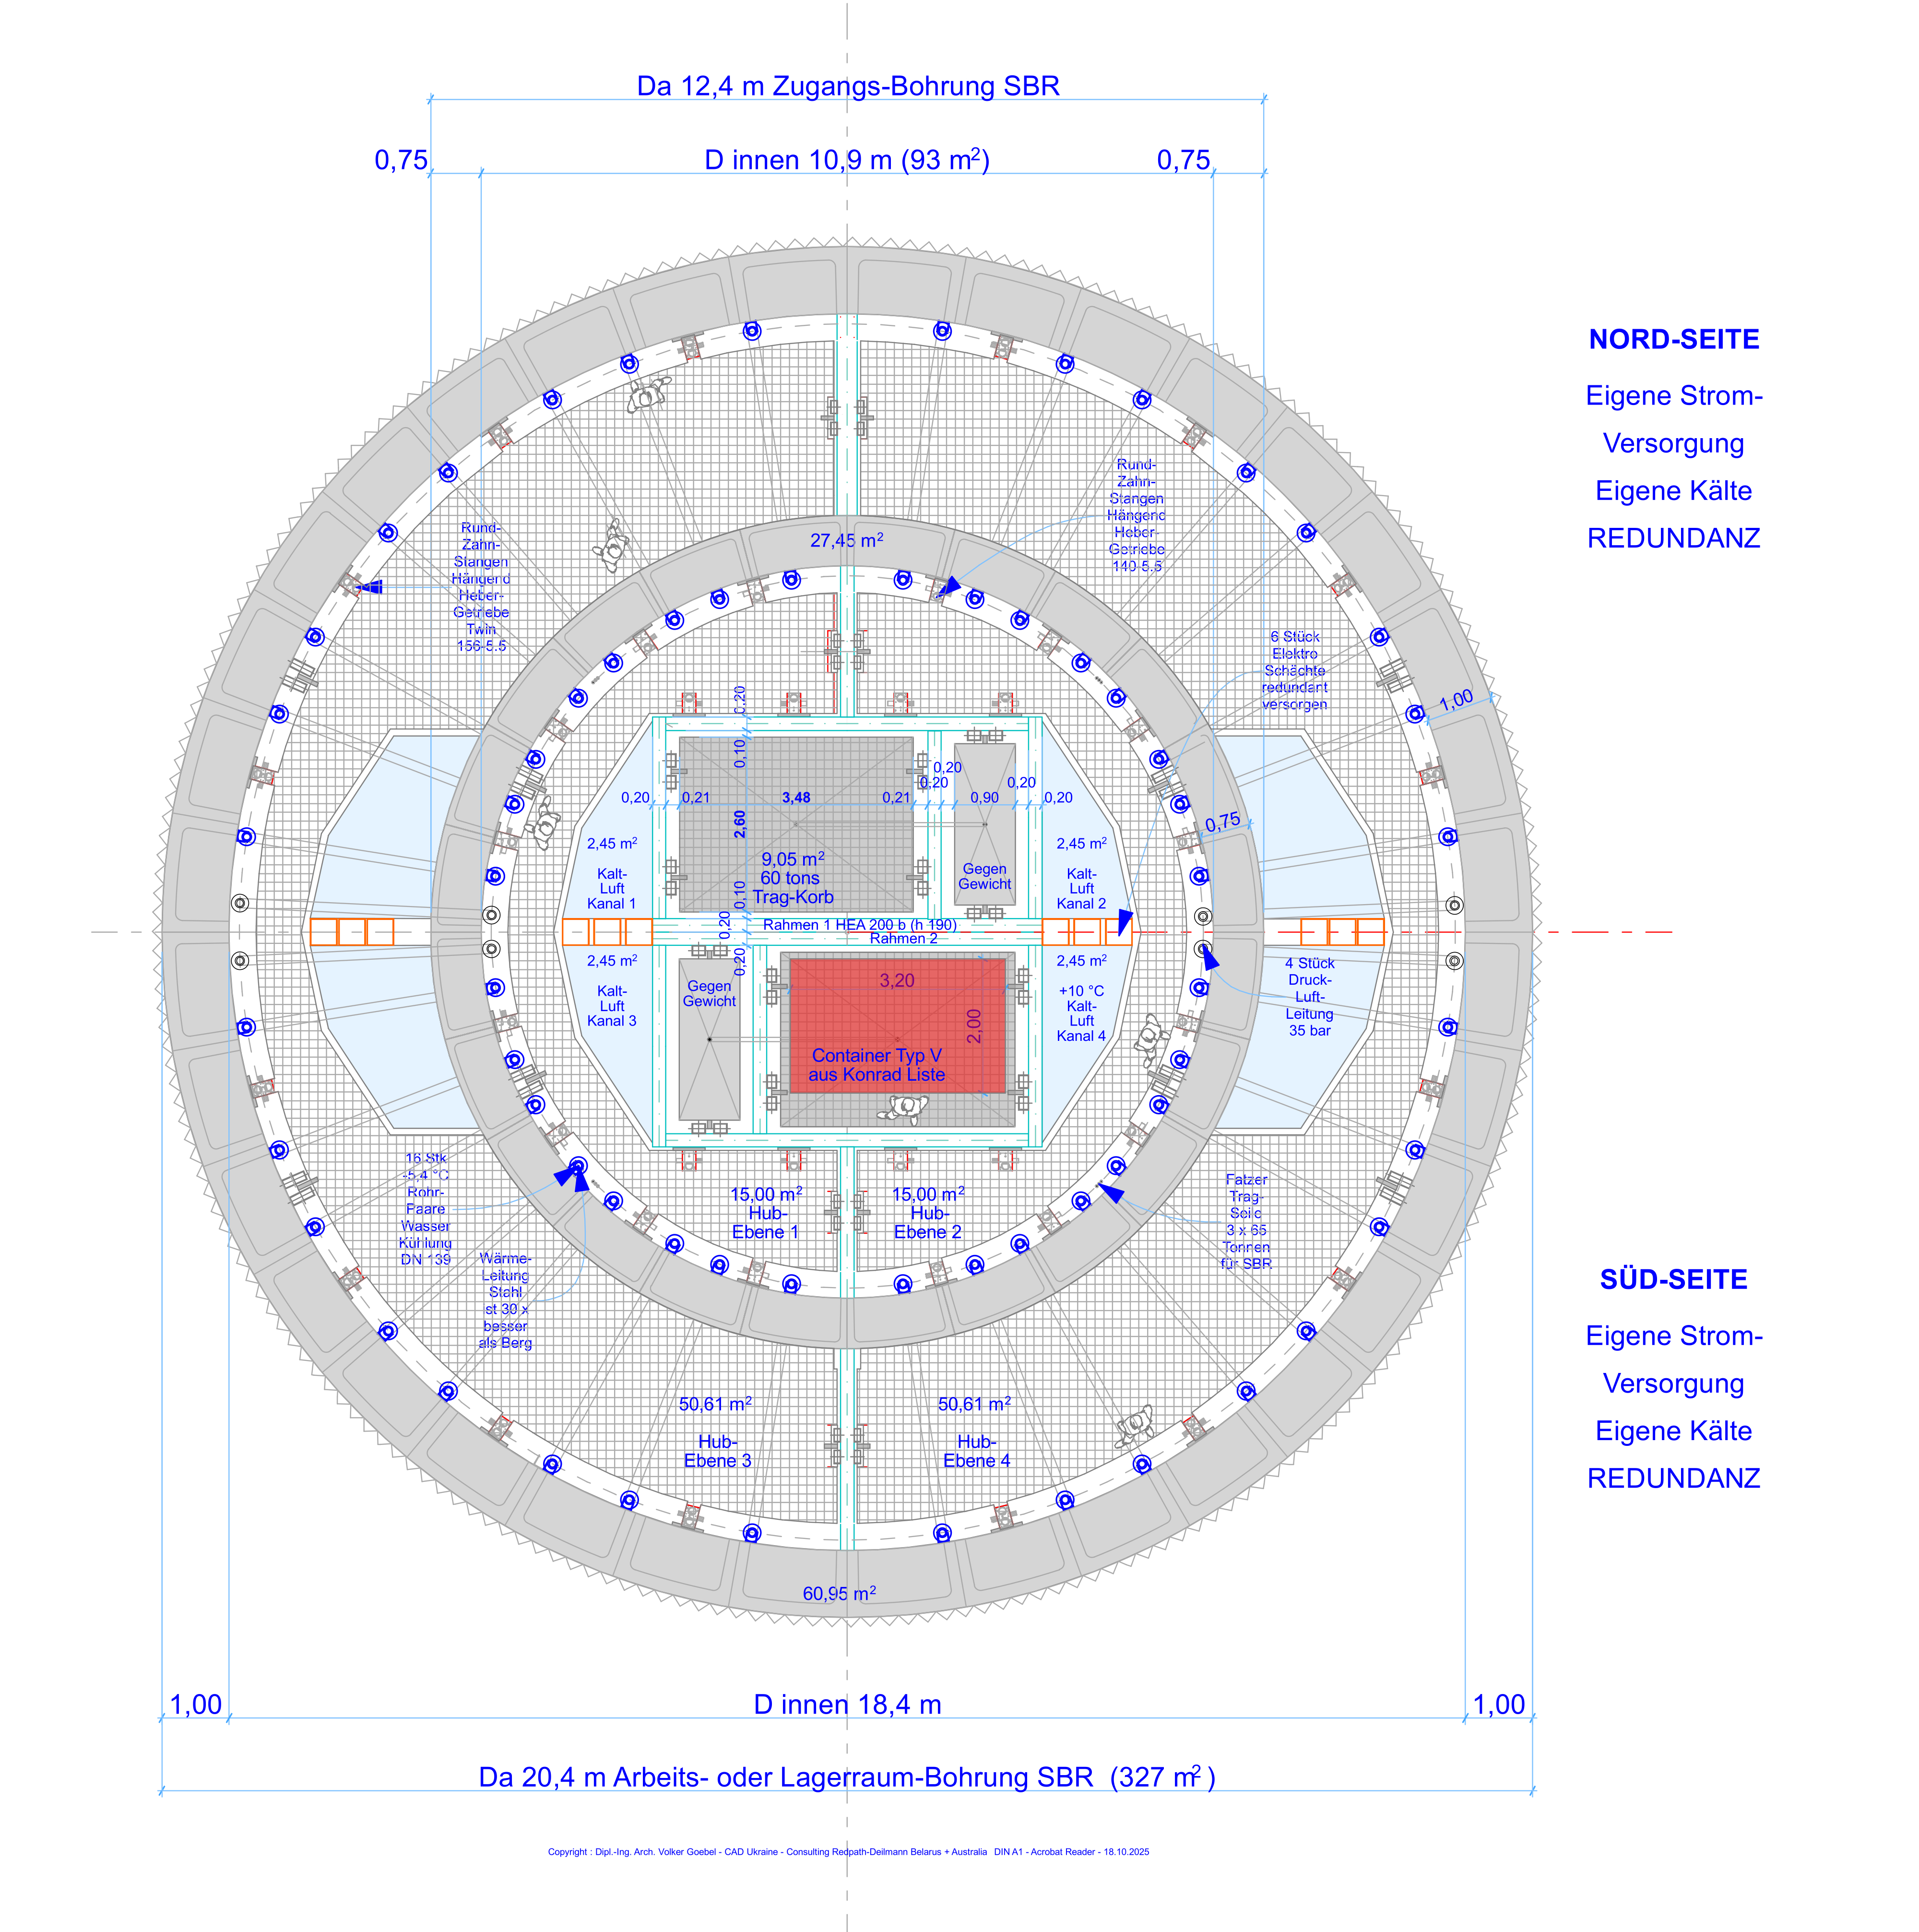
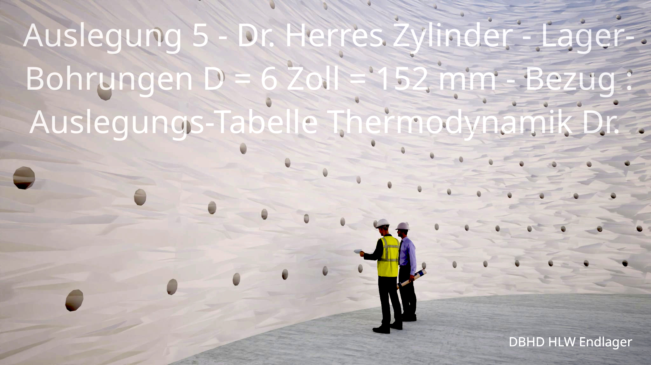

DBHD wants to buy land in Texas – near Houston area and keep distance to the

existing cavernes – knowing that DBHD is usually deeper then the cavernes are.

DBHD is also looking for a salt dome GDF geology up north in Louisiana / USA.

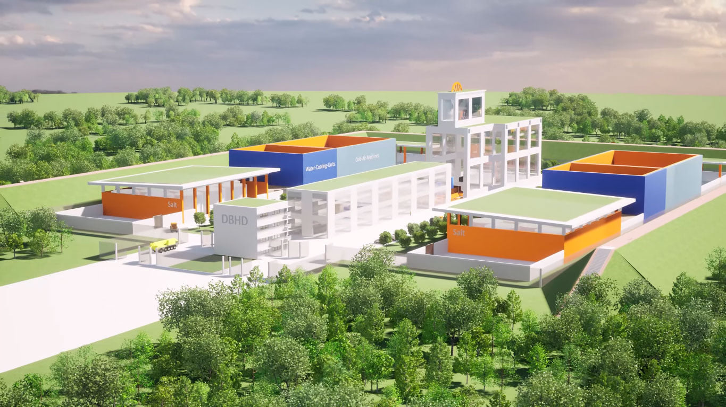

info@ing-goebel.com

www.ing-goebel.de

mention HLW Mg net

mention container type

